2024
- Define Package. Explain steps in creation and implementation of package with example.
Code :
the package is under the hello folder

code of tester.java
package hello;

public class tester {
public int a = 10, b = 20;

public void display() {
System.out.println("This is a package");
}

}

code for spackage.java

import hello.tester;;

public class spackage {
public static void main(String[] args) {
tester d = new tester();
int c = d.a + d.b;
System.out.println("Sum of a and b is: " + c);
d.display();
}
}

- What is multithreading? How does Java support inter-thread communication? Explain with example.

class test extends Thread {
int total = 0;

public void run() {
synchronized (this) {
for (int i = 1; i <= 10; i++) {

total += i;
}
this.notify();
}

}
}

public class inter_thread {
public static void main(String[] args) {

test t = new test();
t.start();

synchronized (t) {

try {
t.wait();
System.out.println("Total is: " + t.total);
} catch (Exception e) {
// TODO: handle exception
}
}

}
}

- How to handle multiple catch blocks for a nested try block? Explain with an example.

public class mtry_catch {
public static void main(String[] args) {

try {
int[] a = new int[2];
a[3] = 5;

int c;
try {
c = 5 / 0;
System.out.println(c);
} catch (ArithmeticException e) {
System.out.println("Arthimetic error");
}
} catch (ArrayIndexOutOfBoundsException e) {
System.out.println("array error");
}

}
}

- Example of String and StingBuffer.

import java.lang.String;
import java.lang.StringBuffer;

public class string_strinBuffer {

public static void main(String[] args) {
String str = "HEllo";
String str1 = "World";
StringBuffer sb = new StringBuffer(str) ;

// String operations
Boolean b1 = str.equals(str1);
System.out.println(b1); // false

System.out.println(str.toUpperCase()); // HELLO

System.out.println(str.concat(str1)); // HElloWorld

System.out.println(str.length()); // 5

// StringBuffer operations
sb.append(str1);
System.out.println(sb); // HElloWorld

sb.setCharAt(4, '-');
System.out.println(sb); // HEll-World
}
}

- Define array and multi dimensional array. Write a program to read two m x n matrices, perform multiplication operation and store result in third matrix.
An array is a linear data structure that stores multiple elements of the same data type under one name. It is indexed, starting from 0.
Features:
• Stores multiple values in a single variable.
- All elements must be of the same type (e.g., all integers or all strings).
- Index-based access (e.g., arr[0] for the first element).

A multidimensional array is an array of arrays. The most common is the 2D array, which is used to represent rows and columns like a matrix or table.
Features:
• Used to represent data in tabular form (like a grid or matrix).
- Each element is accessed using multiple indices.
Code :

import java.util.Scanner;

public class matrix_mul {
public static void main(String[] args) {
int[][] a = new int[3][3];
int[][] b = new int[3][3];
int[][] c = new int[3][3];
int i, j, k;
Scanner s = new Scanner(System.in);
System.out.println("Enter the matrix A");
for (i = 0; i < 3; i++) {

for (j = 0; j < 3; j++) {

System.out.print("Enter element : ");
a[i][j] = s.nextInt();

}

}

System.out.println("Enter the matrix B");
for (i = 0; i < 3; i++) {

for (j = 0; j < 3; j++) {

System.out.print("Enter element : ");
b[i][j] = s.nextInt();

}

}

// Multiplication

for (i = 0; i < 3; i++) {
for (j = 0; j < 3; j++) {
for (k = 0; k < 3; k++) {
c[i][j] += a[i][k] * b[k][j];
}
System.out.print(c[i][j] + " ");
}
System.out.println("");
}

}
}

- Code to add row of each matrx .

import java.util.Scanner;

public class sum_row {
public static void main(String[] args) {

int[][] a = new int[3][3];
int[][] b = new int[3][3];
int i, j;
Scanner s = new Scanner(System.in);

System.out.println("Enter the matrix");
for (i = 0; i < 3; i++) {
for (j = 0; j < 3; j++) {
System.out.println("Enter the element");
a[i][j] = s.nextInt();
}
System.out.println("");
}

for (i = 0; i < 3; i++) {
int sum = 0;
for (j = 0; j < 3; j++) {
// sum += a[i][j]; this is for row
// sum += a[j][i]; for column
b[i][j] = a[j][i]; // for transpose

System.out.print(b[i][j] + " "); // for transpose to give space
}
System.out.println("");
// System.out.println("The sum of " + (i + 1) + " row is " + sum + "");
// System.out.println("The sum of " + (i + 1) + " column is " + sum + "");

}
}
}

- Do all the programs related to file handling.

import java.io.File;
import java.io.FileNotFoundException;
import java.io.FileWriter;
import java.io.IOException;
import java.util.Scanner;

public class createFile {
public static void main(String[] args) {

try {
File f = new File("file.txt");
if (f.createNewFile()) {
System.out.println("File is Created");

} else {
System.out.println("File is already exist");
}
} catch (Exception e) {
System.out.println("File is not created");
}

// writing to file

try {
FileWriter fw = new FileWriter("file.txt");
fw.write("We are from Coding Journey");
fw.close();
System.out.println("File is written successfully");

} catch (IOException e) {
// TODO: handle exception
System.out.println(e.getMessage());
}

// for reading file

try {
File f = new File("file.txt");
Scanner sc = new Scanner(f);
while (sc.hasNextLine()) {
String data = sc.nextLine();
System.out.println(data);

}
sc.close();
} catch (FileNotFoundException e) {
System.out.println("Error in file");
}
// for file info
File f1 = new File("file.txt");
if (f1.exists()) {
System.out.println("File name :" + f1.getName());
System.out.println("File path:" + f1.getAbsolutePath());
System.out.println("File size in byte:" + f1.length());

}
// for delete
File f2 = new File("file.txt");
if (f2.delete()) {
System.out.println("File is deletd of name " + f2.getName());
} else {

System.out.println("File is not deleted");
}
}

}

- Different
- Different
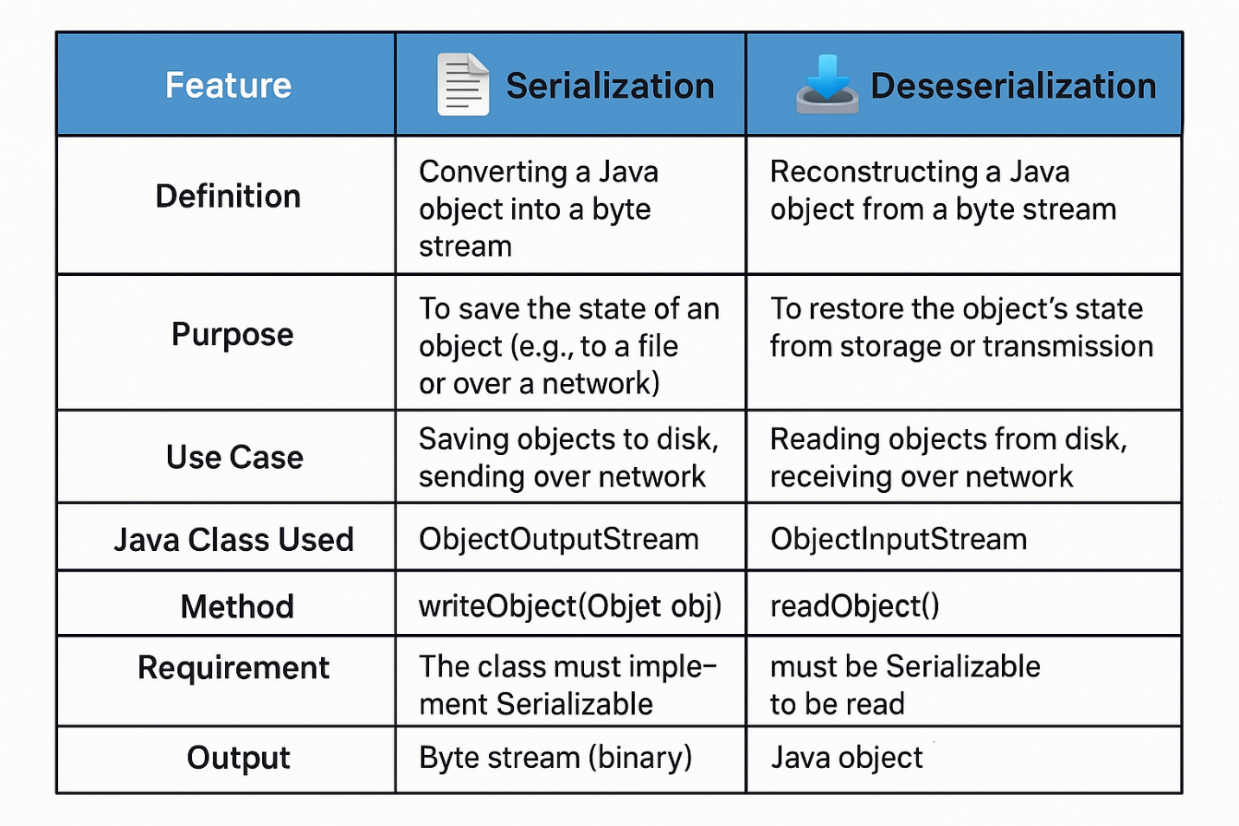
- Different Between

- Write a program to create the following simple GUI based application. If user press the Submit button, your program should store the information in a file named "exam.txt" only when he accepts the terms and condition otherwise it should display a message "please accept the terms and condition first".

import javax.swing.JFrame;
import javax.swing.JLabel;
import javax.swing.JOptionPane;
import javax.swing.JRadioButton;
import javax.swing.JTextArea;
import javax.swing.JTextField;

import javax.swing.ButtonGroup;
import javax.swing.JButton;
import javax.swing.JCheckBox;
import javax.swing.JComboBox;

import java.awt.event.ActionEvent;
import java.awt.event.ActionListener;
import java.io.File;
import java.io.FileWriter;
import java.io.IOException;

public class Gui_Application {
public static void main(String[] args) {
JFrame f = new JFrame("Registration Form");
f.setLayout(null);
f.setVisible(true);
f.setSize(400, 400);
f.setDefaultCloseOperation(JFrame.EXIT_ON_CLOSE);
JLabel l1 = new JLabel("Name");
l1.setBounds(50, 50, 100, 30);
f.add(l1);
JTextField t1 = new JTextField();
t1.setBounds(120, 60, 200, 20);
f.add(t1);
JLabel l2 = new JLabel("Mobile");
f.add(l2);
l2.setBounds(50, 100, 100, 30);
JTextField t2 = new JTextField();
t2.setBounds(120, 110, 200, 20);
f.add(t2);
JLabel l3 = new JLabel("Gender");
l3.setBounds(50, 160, 100, 30);
f.add(l3);
JRadioButton r1 = new JRadioButton("Male");
r1.setBounds(120, 160, 100, 30);
r1.setSelected(true); // to set default selection
f.add(r1);
JRadioButton r2 = new JRadioButton("Female");
r2.setBounds(220, 160, 100, 30);
f.add(r2);
ButtonGroup bg = new ButtonGroup(); // to make only one radio button selected at a time
bg.add(r1);
bg.add(r2);
JLabel l4 = new JLabel("Date of Birth");
l4.setBounds(50, 210, 150, 30);
f.add(l4);
String day[] = new String[32];
day[0] = "DD";
for (int i = 1; i <= 31; i++) {
day[i] = String.valueOf(i);
}
JComboBox<String> d = new JComboBox<>(day);
d.setBounds(150, 210, 60, 30);
f.add(d);

// For month
String month[] = { "MM", "Jan", "Feb", "Mar", "Apr", "May", "Jun", "Jul", "Aug", "Sep", "Oct", "Nov", "Dec" };

JComboBox<String> m = new JComboBox<>(month);
m.setBounds(230, 210, 80, 30);
f.add(m);

// For Year
String year[] = new String[73];
year[0] = "YYYY";
int iyear = 1954;
for (int i = 1; i < year.length; i++) {
year[i] = String.valueOf(iyear++);
}
JComboBox<String> y = new JComboBox<>(year);
y.setBounds(330, 210, 80, 30);
f.add(y);
JLabel l5 = new JLabel("Address");
l5.setBounds(50, 260, 100, 30);
f.add(l5);
JTextArea t3 = new JTextArea();
t3.setLineWrap(true);
t3.setWrapStyleWord(true);
t3.setBounds(150, 260, 500, 80);
f.add(t3);
JCheckBox c1 = new JCheckBox("Accept Terms and Conditions");
c1.setBounds(150, 350, 250, 40);
f.add(c1);
JButton b1 = new JButton("Submit");
b1.setBounds(150, 400, 100, 30);
f.add(b1);

// implementing the logic

b1.addActionListener(new ActionListener() {
public void actionPerformed(ActionEvent e) {
if (!c1.isSelected()) {
JOptionPane.showMessageDialog(f, "Please accept the terms and condition first");

return;
}
String name = t1.getText();
String mobile = t2.getText();
String gender = (r1.isSelected()) ? r1.getText() : r2.getText();
String date = d.getSelectedItem().toString();
String month = m.getSelectedItem().toString();
String year = y.getSelectedItem().toString();
String address = t3.getText();

try {
File f1 = new File("exam.txt");
if (f1.createNewFile()) {
System.out.println("File is created");
} else {
System.out.println("File already exists");
}
FileWriter fw = new FileWriter("exam.txt");
fw.write("Name: " + name + " Mobile: " + mobile + " Gender: " + gender + " Date of Birth: " + date
+ "-" + month + "-" + year + " Address: " + address);
fw.close();
JOptionPane.showMessageDialog(f, "Data saved Successfully");
} catch (IOException ex) {
System.out.println("Error creating file: " + ex.getMessage());
}
}
});
}
}

- WAP to Create a Set with following values: {"London", "NewYork", "SanFrancisco", "Beijing", "NewYork"} Perform operations on above Set:>Add new element>Get Set size>Remove element>Contains element?>addAll>removeAll>retainAll

import java.util.Set;
import java.util.HashSet;
import java.util.Arrays;

public class set {
public static void main(String[] args) {
// Initial Set with duplicate "NewYork" (HashSet ignores duplicates)
Set<String> s = new HashSet<>(Arrays.asList("London", "NewYork", "SanFrancisco", "Beijing", "NewYork"));
System.out.println("Initial Set: " + s);
// Output (order may vary): [London, NewYork, SanFrancisco, Beijing]

s.add("Nepal");
System.out.println("After adding Nepal: " + s);
// Output: [London, NewYork, SanFrancisco, Beijing, Nepal]

System.out.println("Size: " + s.size());
// Output: 5

s.remove("London");
System.out.println("After removing London: " + s);
// Output: [NewYork, SanFrancisco, Beijing, Nepal]

System.out.println("Contains Nepal? " + s.contains("Nepal"));
// Output: true

Set<String> s1 = new HashSet<>(Arrays.asList("India", "Pakistan"));

s.addAll(s1);
System.out.println("After addAll(s1): " + s);
// Output: [NewYork, SanFrancisco, Beijing, Nepal, India, Pakistan]

Set<String> s2 = new HashSet<>(Arrays.asList("Pakistan", "India"));
s.removeAll(s2);
System.out.println("After removeAll(s2): " + s);
// Output: [NewYork, SanFrancisco, Beijing, Nepal]

Set<String> s3 = new HashSet<>(Arrays.asList("Nepal", "SanFrancisco"));
s.retainAll(s3);
System.out.println("After retainAll(s3): " + s);
// Output: [SanFrancisco, Nepal]

System.out.println("Final Set: " + s);
// Final Output: [SanFrancisco, Nepal]
}
}

2023
- What are uses of super keyword? Write a java program to create base class Fruit which hasname, taste and size as its attributes and method called eat() which describe name and its taste.Inherit the same in two other class Apple and Orange and override the eat() method to representeach fruit taste.

class fruits {
int size;
String test;
String name;

fruits(String fname, String ftest, int fsize) {
this.name = fname;
this.test = ftest;
this.size = fsize;
}

void eat() {
System.out.println("Fruits name is " + name + " and test is " + test);
}
}

class Apple extends fruits {
Apple(String fname, String ftest, int fsize) {
super(fname, ftest, fsize); // go to the parent class constructor which is fruits as arguments
}

void eat() {
System.out.println("Fruits name is " + name + " and test is " + test);
}
}

class Mango extends fruits {
Mango(String fname, String ftest, int fsize) {
super(fname, ftest, fsize); // go to the parent class constructor which is fruits as arguments
}

void eat() {
System.out.println("Fruits name is " + name + " and test is " + test);
}
}

public class tester {
public static void main(String[] args) {
Apple a = new Apple("Apple", "Sweet", 5);
Mango m = new Mango("Mango", "Sweet", 6);
a.eat();
m.eat();
}
}

- Palindrom or not

import java.util.Scanner;
public class palindrome {
public static void main (String[] args){
Scanner s= new Scanner(System.in);
System.out.println("Enter a string to check if it is a palindrome:");
String str=s.nextLine();
StringBuffer sb = new StringBuffer(str);
String rvs=sb.reverse().toString();

if(str.equals(rvs)) {
System.out.println("The string is a palindrome");
} else {
System.out.println("The string is not a palindrome");
}
}
}

- Why we need file handling in java? Write java program to read file into a variable and then write a variable's content into another file.

We need file handling in java for following reasons:
- Data Persistence:
Programs usually store data temporarily in memory (RAM), which disappears when the program stops. Files allow data to be saved permanently so it can be used later.
- Reading & Writing Data:
Many applications need to read input data from files or write output data to files — for example, saving user info, logs, or configuration.
- Data Sharing:
Files enable data to be shared between different programs or transferred between systems.
- Storing Large Data:
Files can store large amounts of data that don’t fit or shouldn’t be stored in memory.
- Interaction with External Systems:
Applications often need to interact with files created outside the program — like documents, CSVs, images, or logs.
- Backup and Recovery:
Files allow programs to create backups and recover information if needed.
- Input/Output Automation:
File handling enables automation scripts or batch jobs to process data without user interaction.
Code :
import java.io.File;
import java.io.FileWriter;
import java.io.IOException;
import java.util.Scanner;

public class file {

public static void main(String[] args) {
File f = new File("file.txt");
try (
FileWriter fw = new FileWriter("file1.txt");
Scanner s = new Scanner(f)) {
StringBuilder sb = new StringBuilder();
while (s.hasNextLine()) {
String line = s.nextLine();
sb.append(line).append("\n");
}

fw.write(sb.toString());
// No need to close fw or s explicitly due to try-with-resources
} catch (IOException e) {
System.out.println("Error: " + e.getMessage());
}
System.out.println("File copied successfully");
}
}

- What is the purpose of valueof() method in Wrapper classes? Write a java program to generate random integer, double and bytes.

import java.util.Random;

public class random_Number {
public static void main(String[] args) {
Random r = new Random();
int n = r.nextInt(); // for integer
double d = r.nextDouble();
byte[] b = new byte[1]; // create a array to store 1 element
r.nextBytes(b); // fill array with bytes
byte f = b[0]; // for byte
System.out.println("Random number" + n);
System.out.println("Random double " + d);
System.out.println("Random byte " + f);
}
}

- What is internal frames? Write a java program that display two internal frame within some parentframe.

import java.awt.event.ActionEvent;

import java.sql.Connection;
import java.sql.DriverManager;
import java.sql.Statement;
import java.sql.SQLException;
import javax.swing.*;

public class Student {
public static void main(String[] args) {
// Create the main frame
JFrame f = new JFrame("Student Registration");
f.setSize(500, 400);
f.setLayout(null);
f.setDefaultCloseOperation(JFrame.EXIT_ON_CLOSE);

// Roll No
JLabel rollLabel = new JLabel("Roll No:");
rollLabel.setBounds(100, 50, 100, 25);
JTextField rollField = new JTextField();
rollField.setBounds(200, 50, 150, 25);

// Name
JLabel nameLabel = new JLabel("Name:");
nameLabel.setBounds(100, 90, 100, 25);
JTextField nameField = new JTextField();
nameField.setBounds(200, 90, 150, 25);

// Address
JLabel addressLabel = new JLabel("Address:");
addressLabel.setBounds(100, 130, 100, 25);
JTextField addressField = new JTextField();
addressField.setBounds(200, 130, 150, 25);

// Program
JLabel programLabel = new JLabel("Program:");
programLabel.setBounds(100, 170, 100, 25);
JTextField programField = new JTextField();
programField.setBounds(200, 170, 150, 25);

// Submit button
JButton submitButton = new JButton("Submit");
submitButton.setBounds(180, 230, 100, 30);

// Add components to the frame
f.add(rollLabel);
f.add(rollField);
f.add(nameLabel);
f.add(nameField);
f.add(addressLabel);
f.add(addressField);
f.add(programLabel);
f.add(programField);
f.add(submitButton);

// Show the frame
f.setVisible(true);

// handiling the action

submitButton.addActionListener((ActionEvent e) -> {
try {

int roll = Integer.parseInt(rollField.getText());
String name = nameField.getText();
String address = addressField.getText();
String program = programField.getText();
Class.forName("com.mysql.cj.jdbc.Driver");
try (
Connection con = DriverManager.getConnection("jdbc:mysql://localhost:3306/studentdb", "root",
"");) {

System.out.println("Connection successful ");
Statement st = con.createStatement();
String query = "Insert into student(roll,name,address,program) values('" + roll + "','" + name
+ "','" + address + "','" + program + "')";
st.executeUpdate(query);
}
} catch (ClassNotFoundException | SQLException ex) {
System.out.println("Error:" + ex.getMessage());
}
});
}
}

- What is JDBC? Write java program to connect database studentdb and display all studentinformation (Roll, Name, Address and Program) from Student table.

import java.sql.Connection;
import java.sql.Statement;
import java.sql.DriverManager;
import java.sql.ResultSet;
import java.sql.SQLException;

public class dispaly {
public static void main(String[] args) {
try {
Class.forName("com.mysql.cj.jdbc.Driver");
try (
Connection con = DriverManager.getConnection("jdbc:mysql://localhost:3306/studentdb", "root",
"");) {
System.out.println("Connection successful ");

Statement st = con.createStatement();
String query = "Select * from student";
ResultSet r = st.executeQuery(query);
System.out.println("Data fetched successfully");

while (r.next()) {
System.out.println("roll :" + r.getInt("roll"));
System.out.println("Name :" + r.getString("name"));
System.out.println("Address :" + r.getString("address"));
System.out.println("Program :" + r.getString("program"));
System.out.println("-----------------------------");
}

}
} catch (Exception e) {
System.out.println("Error: " + e.getMessage());
}

}
}

- What is java Buzzwords? Write a java program to find simple interest. Use command line argument to take input.

public class simplecmd {
public static void main(String[] args) {
if(args.length !=3){
System.out.println("Usage : java simpleIntersest ");
return;
}
double p= Double.parseDouble(args[0]);
double r=Double.parseDouble(args[1]);
double t= Double.parseDouble(args[2]);
double si=(p*r*t)/100;
System.out.println("Simple interest is :"+ si);

}
}

- What is Constructor overloading? Write a class Distance containing private variable feet of type int and inches of type int, suitable constructors and three methods addDistance, subtractDistanceand display Distance for adding, subtracting and displaying objects. Write a separate classMyDistance containing main method to create, add, subtract and display distance objects.

class Distance {
private int feet;
private int inches;

public Distance() {
this.feet = 0;
this.inches = 0;
}

public Distance(int feet, int inches) {
this.feet = feet;
this.inches = inches;
normalize();
}

public void normalize() {
if (inches >= 12) {
feet += inches / 12;
inches = inches % 12;
}
}

public Distance addDistance(Distance d) {
int tf = this.feet + d.feet;
int ti = this.inches + d.inches;
return new Distance(tf, ti);

}

public Distance subtractionDistance(Distance d) {
int tf = this.feet - d.feet;
int ti = this.inches - d.inches;
if (ti < 0) {
tf--;
ti += 12;
}
return new Distance(tf, ti);
}

public void displayDistance() {
System.out.println("Distance is : " + feet + " feet " + inches + " inches");
}
}

public class Constructor {
public static void main(String[] args) {
Distance d1 = new Distance(5, 6);
Distance d2 = new Distance(2, 3);
Distance d3 = d1.addDistance(d2);
Distance d4 = d1.subtractionDistance(d2);
System.out.println("Distance 1:");
d1.displayDistance();
System.out.println("Distance 2:");
d2.displayDistance();
System.out.println("Adding distances:");
d3.displayDistance();
System.out.println("Subtracting distances:");
d4.displayDistance();
}
}

- a) What is difference between checked and unchecked exception? Write a java program that willread college name from keyboard and display it on screen. The program should throw an exception when length of college name is more than 50.

import java.util.Scanner;

public class College {
public static void main(String[] args) throws Exception {
Scanner s = new Scanner(System.in);

System.out.println("Enter the name of College:");
String name = s.nextLine();
if (name.length() > 50) {
throw new Exception("Name of college should not be more than 50 characters");
}

}
}

- WAP to throw your own exception

import java.lang.Exception;

class me extends Exception {

me(String message) {
super(message);
}
}

public class Ownexceptiion {
public static void main(String[] args) {

try {
int age = 15;
if (age < 18) {
throw new me("Age is less");
} else {
System.out.println("Age is valid");
}
} catch (me e) {
System.out.println("Exception caught: " + e.getMessage());
}

}
}

- What are methods used for inter-thread communication? Write a java program to create twothreads so that one thread prints even number and other thread prints odd number between 100 and 200.

class Pointer implements Runnable {
static int counter = 100;
int reminder;
static Object ob = new Object();

Pointer(int r) {
reminder = r;
}

public void point() {
System.out.println(Thread.currentThread().getName() + "" + counter++);
}

public void run() {

while (true) {
synchronized (ob) {
if (counter > 200)
break;

if (counter % 2 != reminder) {
try {
ob.wait();
} catch (Exception e) {
System.out.println("Error");
}
} else {

point();
ob.notifyAll();
}

}

}
}
}

public class even_oddnotify {
public static void main(String[] args) {
Pointer even = new Pointer(0);
Pointer odd = new Pointer(1);
Thread eventh = new Thread(even, "Even Number");
Thread oddth = new Thread(odd, "Odd Number");
eventh.start();
oddth.start();
}
}

By using only thread:

class even extends Thread {
public void run() {
for (int i = 100; i <= 200; i++) {
if (i % 2 == 0) {
System.out.println("Even numbers:" + i);
}
}
}
}

class odd extends Thread {
public void run() {
for (int i = 100; i < 200; i++) {
if (i % 2 != 0) {
System.out.println("Odd numbers:" + i);
}
}
}
}

public class odd_even {
public static void main(String[] args) {
even e = new even();
odd o = new odd();
e.start();
o.start();
}
}

What is serialization? Write a java program to write three student information (Roll, Name,Address, College) into file student.txt and display the student information whose address is Jhapa.

Serialization in Java is the process of converting an object into a byte stream, so it can be saved to a file, sent over a network, or persisted in storage. Later, it can be deserialized—reconstructed back into the original object

import java.io.*;

// Student class must implement Serializable
class Student implements Serializable {
int roll;
String name;
String address;
String college;

public Student(int roll, String name, String address, String college) {
this.roll = roll;
this.name = name;
this.address = address;
this.college = college;
}

public void display() {
System.out.println("Roll: " + roll);
System.out.println("Name: " + name);
System.out.println("Address: " + address);
System.out.println("College: " + college);
System.out.println("----------------------");
}
}

public class SerializeDemo {
public static void main(String[] args) {
String filename = "student.txt";

// Create 3 Student objects
Student s1 = new Student(101, "Aarav", "Jhapa", "TU");
Student s2 = new Student(102, "Riya", "Kathmandu", "KU");
Student s3 = new Student(103, "Bibek", "Jhapa", "PU");

// Serialize objects to file
try (ObjectOutputStream oos = new ObjectOutputStream(new FileOutputStream(filename))) {
oos.writeObject(s1);
oos.writeObject(s2);
oos.writeObject(s3);
System.out.println("Student data written to file.");
} catch (IOException e) {
e.printStackTrace();
}

// Deserialize and filter by address = Jhapa
try (ObjectInputStream ois = new ObjectInputStream(new FileInputStream(filename))) {
System.out.println("\nStudents from Jhapa:");
for (int i = 0; i < 3; i++) {
Student s = (Student) ois.readObject();
if (s.address.equalsIgnoreCase("Jhapa")) {
s.display();
}
}
} catch (IOException | ClassNotFoundException e) {
e.printStackTrace();
}
}
}

- Prime or not

import java.util.Scanner;

public class primenumber {
public static void main(String[] args) {
Scanner s = new Scanner(System.in);
int f = 0;
System.out.println("Enter a number");
int n = s.nextInt();

for (int i = 2; i < n; i++) {
if (n % i == 0) {
f++;
break;
}

}

if (f == 0) {
System.out.println("prime");
} else {
System.out.println("non prime");
}
}
}

2022 question Paper
- What is jagged array? Write a java program to initialize and display jagged array element with sum of each row.

public class jagged {
public static void main(String[] args) {
int a[][] = { { 1, 2, 3 }, { 1, 2, 3, 4 }, { 1, 2, 3, 4, 5 } };
int n = a.length;
for (int i = 0; i <= n; i++) {
int r = 0;
for (int j = 0; j < a[i].length; j++) {
r += a[i][j];
}
System.out.println(r);
}
}
}

- Why inheritance is needed in java? How will you implement multiple inheritance using interface? Explain with program.

interface add {
public void sum(int x, int y);

}

interface sub {
public void diff(int a, int b);

}

class Calculation implements add, sub {

public void sum(int x, int y) {
int c = x + y;
System.out.println(c);
}

public void diff(int a, int b) {
int d = a - b;
System.out.println(d);
}
}

public class multiple {
public static void main(String[] args) {
Calculation ca = new Calculation();
ca.sum(5, 4);
ca.diff(6, 5);

}
}

- Example of Synchronization

class Counter {
synchronized void print(){
for(int i= 1;i<=5;i++){
System.out.println("Thread" + Thread.currentThread().getName()+ "-" + i);
try{
Thread.sleep(100);
}
catch(InterruptedException e){
System.out.println(e);
}
}
}
}
class MyThread extends Thread {
Counter co;
MyThread(Counter c){
this.co=c;
}
public void run(){
co.print();
}
}

public class Synchronization {
public static void main(String [] args){
Counter c= new Counter();
MyThread t= new MyThread(c);
MyThread t2=new MyThread(c);
t.start();
t2.start();

}
}

- What is multithreading? Explain with program how you will create thread by implementing runnable interface and extending Thread class.

Using Runnable

class Students implements Runnable {
public void run() {
for (int i = 0; i < 10; i++) {
System.out.println("Thread" + Thread.currentThread().getName() + "-" + i);
}
}
}

class Teacher implements Runnable {
public void run() {
for (int i = 20; i < 30; i++) {
System.out.println("Thread:" + Thread.currentThread().getName() + "-" + i);
}
}
}

public class runable {
public static void main(String[] args) {
Students s = new Students();
Teacher t1 = new Teacher();
Thread tt = new Thread(t1, "teacher");
Thread t = new Thread(s, "student");
tt.setPriority(Thread.MAX_PRIORITY);
t.start();
tt.start();
}
}

Using thread class

class A extends Thread {
public void run() {
for (int i = 1; i < 10; i++) {
int n = 2;
System.out.println(n * i);
}
}
}

class B extends Thread {
public void run() {
for (int i = 1; i < 10; i++) {
int n = 3;
System.out.println(n * i);
}
}
}

public class ThreadClass {
public static void main(String[] args) {
new A().start();
new B().start();
}
}

- What are exception handling keyword in java? Write java program to illustrate the conceptof NullPointerException and NumberFormatException.

public class ExampleException{
public static void main (String[] args){
try{
String a=null;
int count=a.length();
}
catch(NullPointerException e){
System.out.println("Null pointer");
}

try{
String b="Bikram";
int a= Integer.parseInt(b);
}
catch(NumberFormatException e){
System.out.println(e);
}
}
}

- What is Wrapper class? Explain with program, how will you use iterator and comparator in collection objects?

import java.util.ArrayList;
import java.util.Iterator;
import java.util.Comparator;
import java.util.Collections;

public class MyItearator{
public static void main(String[] args){
ArrayList<String> list= new ArrayList<>();
list.add("Bob");
list.add("Bikram");
list.add("Ram");

Iterator <String> it= list.iterator();

while(it.hasNext()){
System.out.println(it.next());
}

//for comparator

Collections.sort(list,new Comparator <String>(){
public int compare(String s1,String s2){
return s1.compareTo(s2);
}
});

System.out.println("Sorted List");

it=list.iterator();

while(it.hasNext()){
System.out.println(it.next());
}
}
}

- How AWT is differing from Swing? Write a GUI program using components to find factorial and cube of number. Use TextField for giving input and Label for output. The program should display factorial if user press mouse on result button and cube if user release mouse from result button.

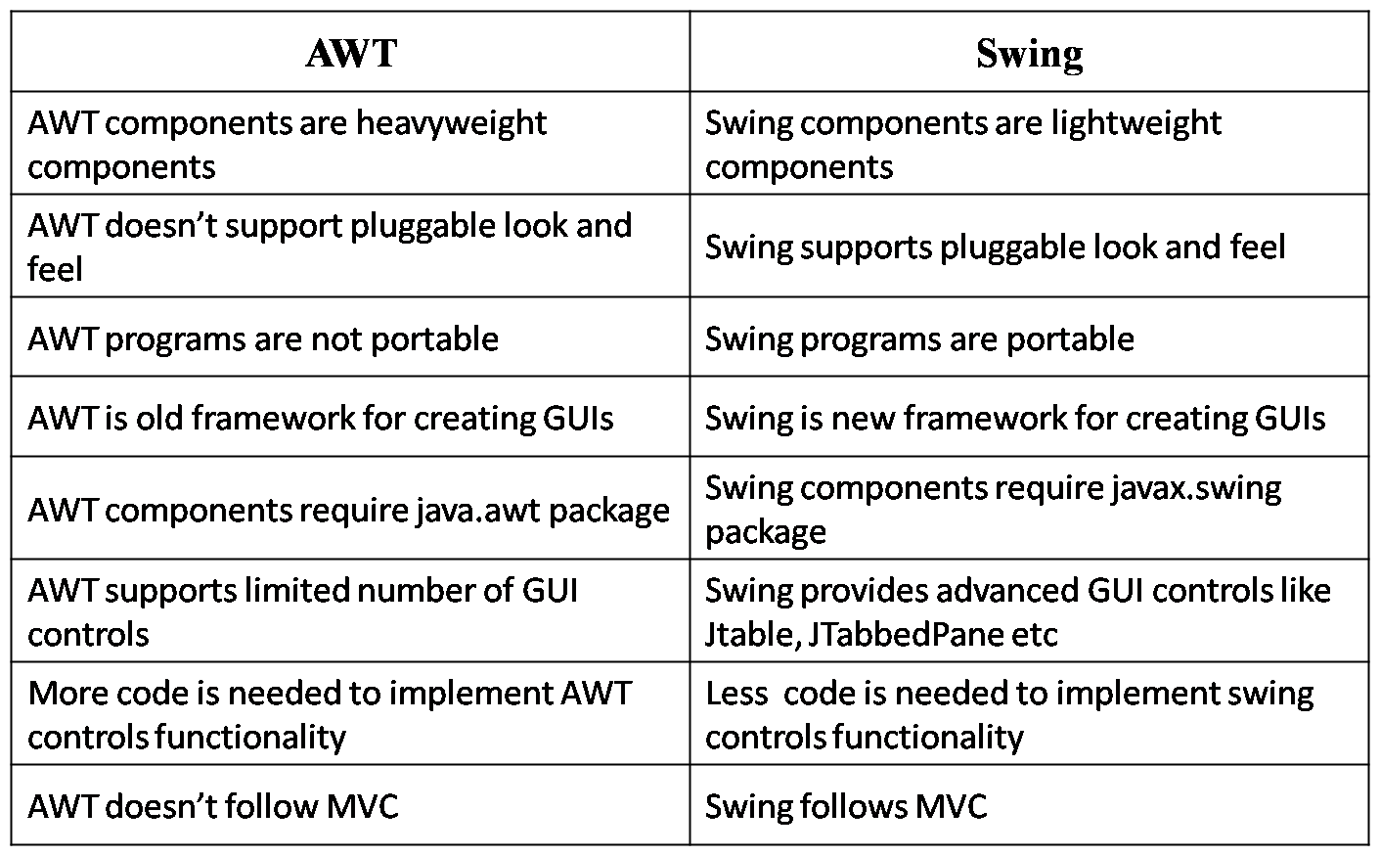

Code :

import javax.swing.JPanel;
import javax.swing.JLabel;
import javax.swing.JTextField;
import javax.swing.JFrame;
import javax.swing.JButton;
import java.awt.event.MouseAdapter;
import java.awt.event.MouseEvent;
import javax.swing.JOptionPane;

class GuiFact {
public static void main(String[] args){
JFrame f= new JFrame("Factorail");
f.setLayout(null);
f.setSize(400,400);
f.setVisible(true);
f.setDefaultCloseOperation(JFrame.EXIT_ON_CLOSE);
JTextField t1= new JTextField();
t1.setBounds(50,100,100,30);
f.add(t1);

JLabel l= new JLabel();
l.setBounds(50,150,100,30);
f.add(l);

JButton b = new JButton("Result");
b.setBounds(50,200,100,30);
f.add(b);

b.addMouseListener(new MouseAdapter(){
public void mousePressed(MouseEvent e){
try{
int n= Integer.parseInt(t1.getText());
int fac=1;
for(int i=1;i<n;i++){
fac*=i;
}

l.setText("Fact " + fac);

JOptionPane.showMessageDialog(f,"The factorial is " +n+ " is "+fac); // to show message in dialog
}
catch(NumberFormatException ex){
l.setText("Invalid number");
}
}

public void mouseReleased(MouseEvent e){
try{

int n = Integer.parseInt(t1.getText());
int r= n*n*n;
l.setText("Cube "+ r);
JOptionPane.showMessageDialog(f,"The cube of "+n+ " is " +r);
}
catch(NumberFormatException ex){
l.setText("Not in format");
}

}
});
}
}

- What is JDBC? Write a java program to connect database Company and insert 5 employeerecord (EID, Ename, Salary, Department) in Employee table and display the employee record who's Department is "Sales".

import java.sql.Connection;
import java.sql.Statement;
import java.sql.DriverManager;
import java.sql.ResultSet;
import java.sql.SQLException;

public class Employee {

public static void main(String[] args) {
try {

Class.forName("com.mysql.cj.jdbc.Driver");

try (
Connection con = DriverManager.getConnection("jdbc:mysql://localhost:3306/studentdb", "root", "")) {

System.out.println("Database connected");

Statement st = con.createStatement();

// Corrected SQL queries
String[] queries = {
"INSERT INTO employee VALUES (1, 'RAM', 3000, 'HR')",
"INSERT INTO employee VALUES (2, 'HARI', 4000, 'SALES')",
"INSERT INTO employee VALUES (3, 'BIKRAM', 50000, 'SALES')",
"INSERT INTO employee VALUES (4, 'Gita', 47000, 'IT')",
"INSERT INTO employee VALUES (5, 'Sita', 48000, 'Sales')"
};

// Proper loop
for (String query : queries) {
try {
st.executeUpdate(query);
System.out.println("Inserted: " + query);
} catch (SQLException e) {
System.out.println("Error inserting: " + query);
}
}

ResultSet rs = st.executeQuery("SELECT * FROM employee WHERE department='sales'");
System.out.println("Employe of department sales");
while (rs.next()) {
System.out.println("Eid : " + rs.getInt("eid") + ",Name : " + rs.getString("ename") + ",Salary: "
+ rs.getInt("salary") +
",Department " + rs.getString("department"));
}
}
} catch (SQLException | ClassNotFoundException ex) {
System.out.println("Error: " + ex.getMessage());
}
}

}

